MAT 3749 1.3 Part III Handout
Closed Sets
A set is closed if its complement is open.

Example 1
(a) is closed.

(b) For with , is closed.

(c) The empty set is closed.

(d) is closed.

(e) Any finite set is closed.

(f) The set is not closed.

(g) The set is closed.

(h) and are the only two subsets of that are both open and closed.

Theorem
1. The intersection of arbitrary collection of closed sets is closed.
2. The union of a finite number of closed sets is closed.

Proof

Open Cover
An open cover of a set is a collection of open sets such that .

Finite Subcover
A finite subcover of is a finite collection of sets of such that .

Compact Sets
A set is compact if every open cover of has a finite subcover.

Example 2
is not compact.

Analysis

We need to construct an open cover of without a finite subcover.

Let us try this popular cover of .
Let for .

Draw a diagram to illustrate along with , , , “” , that leads to and beyond.

How does relate to ? Why?

Let us pick a finite subcover, say
, , , , .

Draw a diagram to illustrate along with the finite subcover above.

Select a “convenient” point in , but not in the subcover above.

Why ?

With the experience of working with one particular finite subcover, let us work with a general finite subcover of .

Let be a finite subcover of . We order the indices such that
.

Explain why implies

Simplify

What is a “convenient” point in , but not in the subcover above?

Proof
Let for . Then . (HW)

Suppose has a finite subcover with .

If , then .

Thus, for all .

So, .

Now, and .

This implies that which contradicts the assumption that is a finite subcover.

So, does not have a finite cover. Thus, is not compact.

Recall: The Completeness Axiom
Let E be a non-empty subset of .
1. If E is bounded above, then E has a least upper bound.
2. If E is bounded below, then E has a greatest lower bound.

Bounded Sets
A set is bounded if it is bounded above and below.

Heine-Borel Theorem
A subset of is compact iff it is closed and bounded.

Theorem 13
The continuous image of a compact set is compact.

Lemma
If is closed and exists, then . (HW)

Extreme Value Theorem (Generalized)
A continuous function on a (non-empty) compact set attains its maximum value at some point of .

Analysis

This is a generalized version of the one we see in 2.3 Part III. As a closed interval are both closed and bounded. Thus, it is compact.

We know …

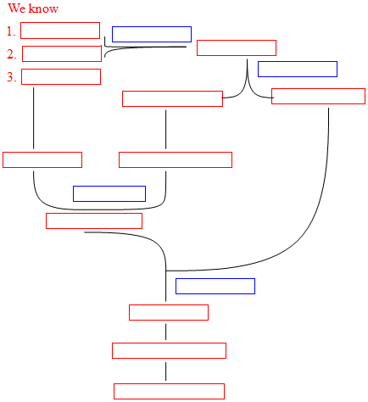

Proof

Since is continuous and is compact, by Theorem 13, is compact.
So, by the H-B Theorem, is closed and bounded.
Since is non-empty, is nonempty.
Since is nonempty and bounded above, by the completeness axiom, exists. Let .
Since is closed, by lemma, .
So, such that .
Since , , for all
Therefore, attains its maximum value at some point of .

